CoreCard Software

DataBase Coding Guidelines

17th Feb 2014
Yogesh Jain

Revision Chart

Version | Primary Author | Description of Version | Date
1.0 | Yogesh Jain | Initial Draft | 02/17/14
1.1 | Yogesh Jain | Added points as suggested by Mark | 03/26/14
1.2 | Yogesh Jain | Added Points after discussion in SQL Session | 04/10/14
1.3 | Yogesh Jain | Added new section for Rollback script guidelines. | 08/26/2015
SVN Location :-
svn://10.205.10.31/Applications/CoreBankCard/CNB/Coding_Guideline/

Following are the guidelines for good and optimized codding practice in
Database : -

- Use SET NOCOUNT ON at the beginning of Stored Procedure that is just below ‘AS’ statement. This will reduce the network round trips your SQL will have to make.

- Choose appropriate datatype for each column that will fit into requirement.

- While creating New Index make sure to follow correct naming convention.
Like - Ixd_TAbleName_[Initials Of ColumnName ]_[Initials Of ColumnName ]...
eg:- Idx_Bsegment_Primary_CID_ActTyp

- Place all your DDLs like temp table definition, Table variable and Variable declaration at the top of stored procedure which is just below the ‘SET NOCOUNT ON’ statement. All DMLs should follow the DDLs. This will increase the chance of plan reuse.
- Always Add Header in all Scripts ,SPs,Trigger etc on top of its defination.
Like -
/*********************************************************************/
-- Author : Author Name
-- Date : Date Of Initial Draft
-- Description : Purpose of this Script/SP etc..
-- Script Location : SVN Location
-- Instruction : Instruction to execute this Script/SP
-- Modification Hist : PersonName : Modification Date : Modification Details
-- Test Call : in case of SP write "Exec SP_Name <Parameter>" statement
/*********************************************************************/

- Use CREATE TABLE SYNTAX to create temp table or Base table rather than using SELECT ..INTO statement.
- Script out the stored procedure to include IF EXISTS DROP statement, and then CREATE statement for new one

- Use COMMENTED lines for different code blocks inside stored procedure so that Developer can identify the functionality easily.

- Error Handling: TRY Block contains the instructions that might cause an exception. If an exception occurs from one of the statements in the TRY block, control is branched to the CATCH block, where the exception can be handled, logged, and so on.

BEGIN TRY
INSERT INTO Table_Name(EmployeeID, EmployeetName) VALUES(1, 'Test')
END TRY
BEGIN CATCH
SELECT 'There was an error! ' + ERROR_MESSAGE()
END CATCH

- Use sp_executesql stored procedure when you need to execute a string of Transact-SQL (Parametrized or Dynamic) instead of the EXECUTE statement. This prevents SQL injection.

- When INSERT operation is taking place in a stored procedure, always specify the column names to avoid issues when a column is added to the table.

- If your stored procedure does not require ‘Transaction safety’ use the ‘NOLOCK’ table hint.A table hint lets the SQL Engine ignore and not perform locks for a given operation.

- Avoid Cursors in T-SQL coding. Cursor does row by operation which causes network traffic ultimately degrade the performance. You can use below alternatives to cursor:

- Temp table with Identity column and WHILE Loop.
set nocount on
declare @i int --Iterator
declare @Rcnt int --Rowcount
declare @Value varchar(100)
set @i = 1 --Initialize
create table #tbl(ID int identity(1,1), Value varchar(100))
insert into #tbl(Value) select name from master..sysdatabases (nolock)
set @Rcnt = @@ROWCOUNT
while @i <= @Rcnt
begin
select @Value = Value from #tbl where ID = @i
--begin tran
print 'My Value is ' + @Value
--commit tran
set @i = @i + 1
end
drop table #tbl
- Temp table without ID and WHILE Loop.
set nocount on
declare @i int
declare @Rcnt int
declare @Value varchar(100)
set @i = 1
create table #tbl(Value varchar(100))
insert into #tbl(Value) select name from master..sysdatabases (nolock)
set @Rcnt = @@ROWCOUNT
while @Rcnt > 0
begin
select top 1 @Value = Value from #tbl
set @Rcnt = @@ROWCOUNT
if @Rcnt > 0
begin
--begin tran
print 'My Value is ' + @Value
--commit tran
delete from #tbl where value = @Value
end
end
drop table #tbl
- Selecting a comma-delimited list of items.
declare @vrs varchar(4000)
declare @sTbl sysname
set @sTbl = 'TableName'
set @vrs = ''
select @vrs = @vrs + ', ' + name from syscolumns where id = (select st.id from sysobjects as st
where name = @sTbl) order by colorder
set @vrs = right(@vrs, len(@vrs)-2)
print @vrs

- Try to use Derived tables,CTE or UNION, UNION ALL statements when possible, instead of temporary tables to gain better performance.

- Table variables should be used for fewer rows (Less than 200) and temporary tables should be used to handle large number of rows. Create Clustered Indexes on temporary table when you define temporary table. Non clustered Indexes can be created after its data load in stored procedure.

- Named constraints should never be used for temporary table since concurrent executions can cause a name collision and it prevent temporary table caching.

- Use ANSI-Standard JOINs rather than using non ANSI standard joins. ANSI-Standard joins help developers in future SQL Server up gradation.
Wrong way -
select * from TableName1 , TableName2
Correct Way -
select * from TableName1 A Join TableName2 B on(A.ColumnName =B.ColumnName)

- Avoid dynamic SQL statements as much as possible. Dynamic SQL is slower than static SQL, as SQL Server must generate an execution plan every time at run-time.

- Avoid using 'sp_' as a prefix for stored procedures as this indicates System Stored Procedure..

- Try avoiding Count(*) in Query.
Wrong way -
select Count(*) from TableName With(NOLOCK)
Correct Way -
select Count(1) from TableName With(NOLOCK)
or
select Count(Column Name) from TableName With(NOLOCK) (Column name must be Primary Column)

- There was a false assumpetion that NOLOCK hint can be used with out WITH keyword.
Wrong way -
select * from TableName NOLOCK
Correct Way -
select * from TableName With(NOLOCK)

- Specially for Dbbide (CNB Project ),we also have composite SPs that need to be considered when ever you make any alteration of following tables
  - Whenever any column is added in any of the tables of Logo make sure to update the composite SP Sp_qryBsGetProd. Following are the table names.
    - Logo_Primary
  - Logo_Secondary
  - LogoPrePaid
  - Logo_Balances
  - LogoFL
  - Logo_MC
  - LogoVS

2 Whenever any column is added in any of the tables of BSegment make sure to update the composite SPs sp_BSegment_Composite_qslk and sp_BSegment_Composite_qsel. Following are the table names.
    - BSegment_Primary
    - BSegmentFL
    - BSegment_Balances
    - BSegmentPP
    - BsegmentBaseAuth
    - BSegmentBrightNow
    - BSegmentCBScore
    - BSegmentCreditCard
    - BSegmentFleetAuth
    - BSegmentInsurance
    - BSegmentLoyality
    - BsegmentFees

3 Whenever any column is added in any of the tables of Ccard make sure to update the composite SP SP_ccardTrancomposite_selq. Following are the table names.
    - Ccard_Primary
    - Ccard_Secondary
    - CcardTransactionMC
    - CCardTransactionVS

4 Whenever any column is added in any of the tables of Auth make sure to update the composite SP SP_AuthTrancomposite_selq. Following are the table names.
    - Auth_Primary
    - Auth_Secondary
    - Auth_MDS1
    - Auth_MDS2
    - Auth_Visa
    - Auth_Discover
    - Auth_Frys
    - Auth_PB
    - Auth_Pulse

23. Guidelines to be followed for Naming convention of Tables :-
    - Proper meaningful name should be provided to Tables.
    - Naming convention for Temporary tables created for Debuging,CodeFixing etc. Which can be deleted after some months should be like "Temp_TableName_MM-DD-YYYY", so that we can easily identify the Older/Unused temp tables using query and monthly remove them.
    - Do not use "TEMP" keyword in 'Table Name' ,if is being used in Application DSL/SP or Reporting and which must not be deleted in monthly cleanup.

  - Only For Archival Database of CNB Production Enviroment -
When ever you are making any schema change in below tables on CNB Production you need to consider that, this perticular change will also be made in 'Archival Database ' of CNB ProductionEnviroment ,so that your change will not break Weekly/Daily Purging Process .
Following are the list of tables you need to consider for this -
  - PrePaid_CAuth Db:
    - CoreAuthTransactions
    - CoreIssueAuthMessage
    - FraudAuthAccounts
    - PooledFundsAcctsBalanceAudit
  - PrePaid_CI Db:
    - LetterInterface
    - TCIVRRequest
    - PeriodicEmailSMSLog
    - PostilionDetails
    - LedgerSettlementAccounts

- While creating 'Sql Query' or 'Query belongs to SPs' you need to check following things :-
- Select only those columns which are needed for your logic.
- Only required tables must be JOINED in query, do not JOIN unnecessary tables.
- 'ON' condition must only contains the Key columns participated in linking of those tables.
- Do not use 'OR' operator in 'ON' condition of JOIN .
- Where condition must contains the column used to filter the records.
- You need to check 'Display Estimated Execution Plan' or 'Actual Execution Plan' for queries.
- Columns used in WHERE condition must have a index or should be a part of Index.
- Try to use PrimaryKey column in your WHERE condition.
- Columns which filter most of the record must be kept first, as the sequence also matters in index selection.
- There should not be unnecessary columns in where condition.
- Try to minimize the use of TypeCasting/Aggrigate and other type of function during comparison in WHERE condition.Try to minimize the use of TypeCasting/Aggrigate and other type of function during comparison in WHERE condition.
- Look to convert 'Table Scan' into 'Index Seek' with proper use of indexed columns.
- If it is needed to add new index on some column then make sure to discuess it with Lead/DBA before adding it.
- While designing New tables all the columns must be declared with proper DataType, take help of leads/Expert in this.
Because during coding we are declaring variable based on the DataType we had in table for that column.

- Try using VARCHAR in place of CHAR untill it is needed.
- Variable must be declater with DATATYPE considering its respective column's datatype already having in TABLE.
- All the columns going to hold ACCTID of any table must be declared as Decimal(19).
It was observed most of the time developers declared it as INT due to which bigger values got corrupted .
- If you need to only check that value in table exist or not, in that case you must use 'TOP 1' in place of COUNT(1).below are the query with Execution Plan to describe it most.

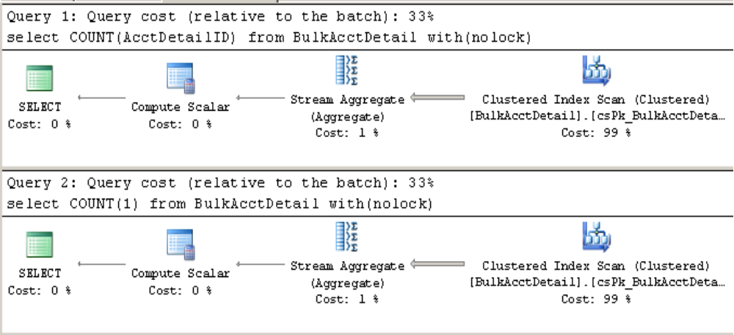

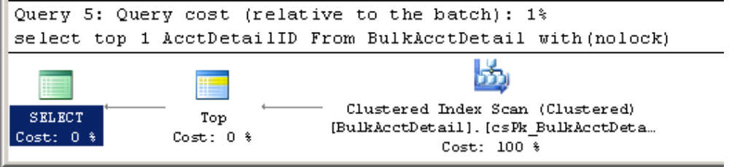
So above diagram demonstrate that for this requirement inside IF EXIST() 3rd query will perform best.

- Some time to convert INDEX SCAN into INDEX SEEK you need to add generalize where condition in indexed column.

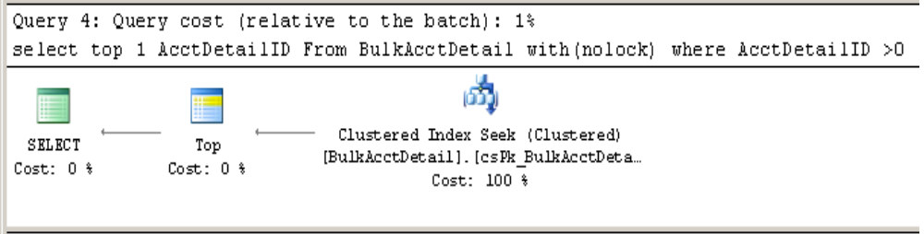
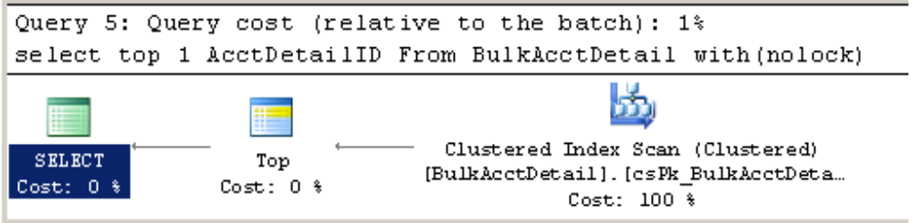

Here Query 4 is showing Index Seek while Query 5 is having Index Scan

- Stop retriving Defination of Objects like SP,Trigger,Function etc using SP_HelpText
this will currupt the defination also during checkin it will show lots of differences.Try retriving its defination from Sql Server Management Studio.
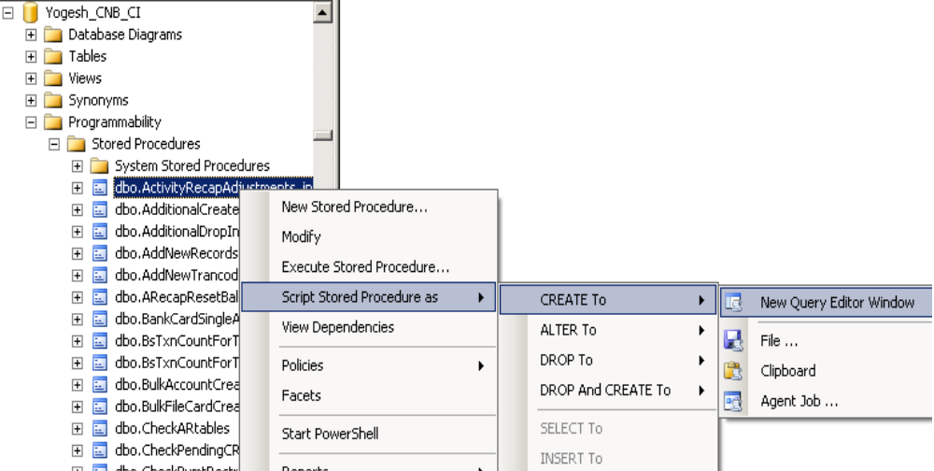

- Rollback Script Guidelines needed during SQL checkins
All developers must follow below points while doing SQL Checkins :-
(Note : Currently it is applicable for CNB checkins but not for WireCard currently , Once WC will have their own running Production Env ready then probably same will be applicable for it. )
  - For all types of sql fix all of you are required to do entries in Attached 'Checkin_Detail_Log_forRollback.txt' file also.This file are stored in module's root folders.
Leads are requested to add this file (Who so ever creating Folder for checkins) in main folders like CI,CL,CAuth,CM etc.

  - All the data fix (Other than Create,Alter,SP ) must be placed in RunManually Folder.
When ever any of you are adding any data fix in RunManually Folder.it must also include Rollback of that script in commented form just below your code .
like in below example existing behavior is in Green & Expected behavior is in RED :-
--------BEG|Added By:Rsingh|Purpose: TD:133301, Lookup insert for EmbossingRever|--------------
insert into ccardlookup(Lutid,LutCode,LutDescription,LutLanguage,DisplayOrdr,Module) values('EmbossingRevert','0','Keep As Is','dbb',1,'PP')
------------------------------- ROLLBACK ------------------------------------------------------------------------------
-- Delete from ccardlookup where Lutid ='EmbossingRevert' and LutCode='0' and Module='PP'
-------END|Added By:Rsingh|Purpose: TD:133301, Lookup insert for EmbossingRevert|------------
Responsibility :-
Developer who is adding SQl fixes are primarily responsible in case Details are missing or not proper as mentioned above other than that Leads are requested to verify these things also during Code review.
You can always take help of respective lead under whose guidance you are making changes.

